Created postman collection for Cohere Endpoints, create API Keys and able to get the result
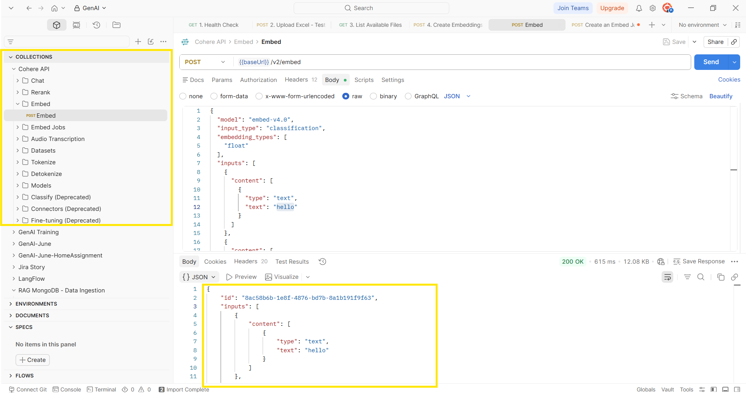

Also updated the RAG tool to support embedding with both Mistral and Cohere
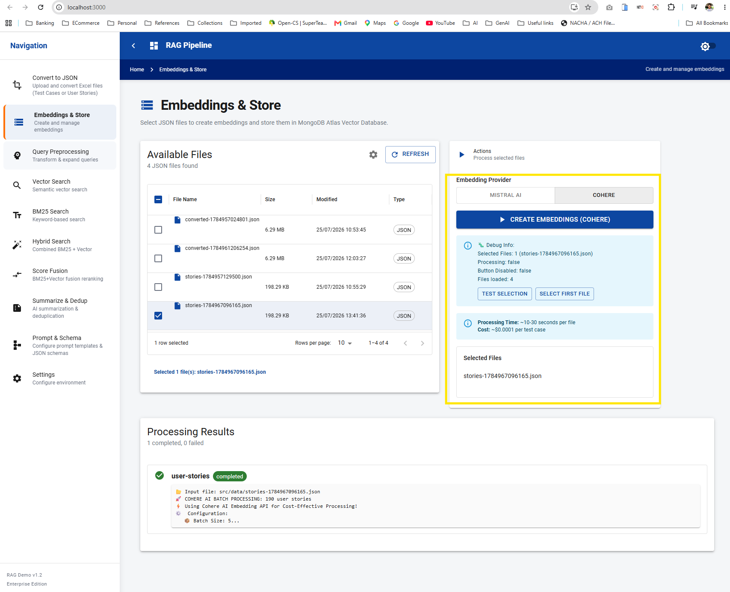
- Upload test case and convert to JSON
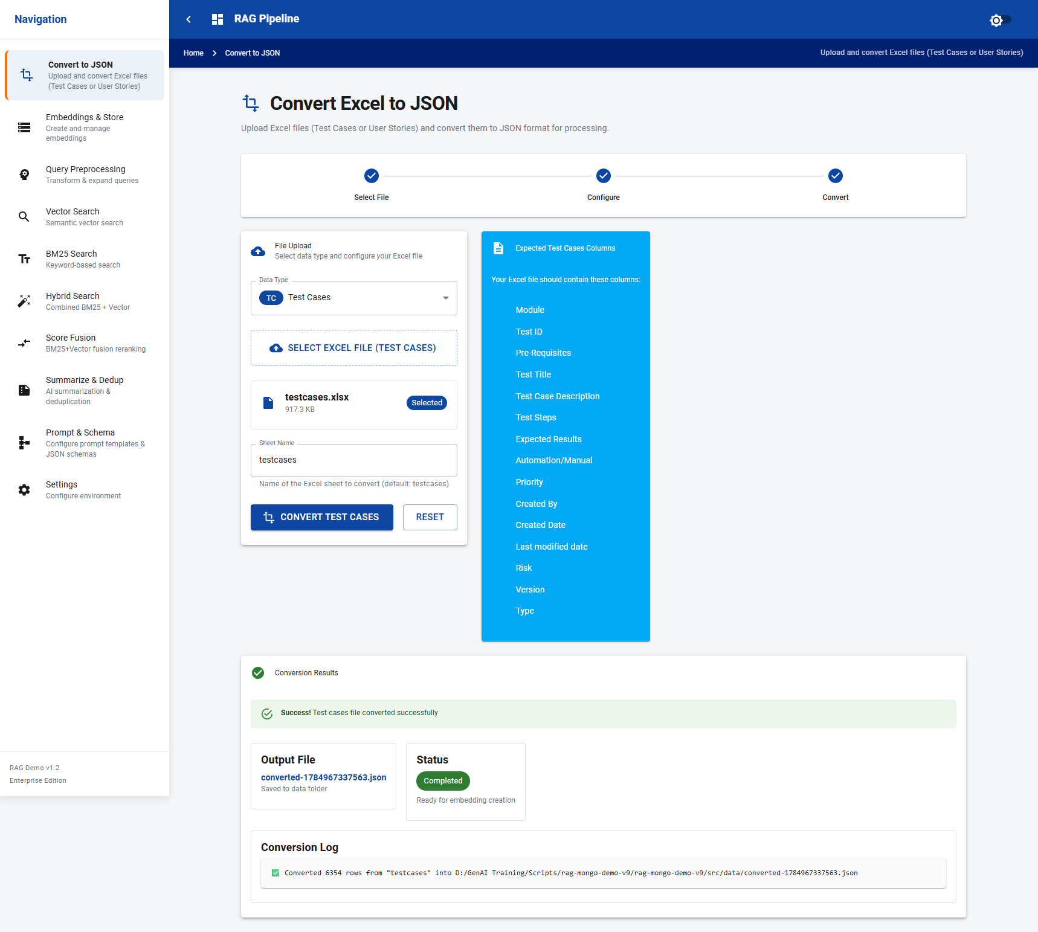

- Create Embedding using Cohere
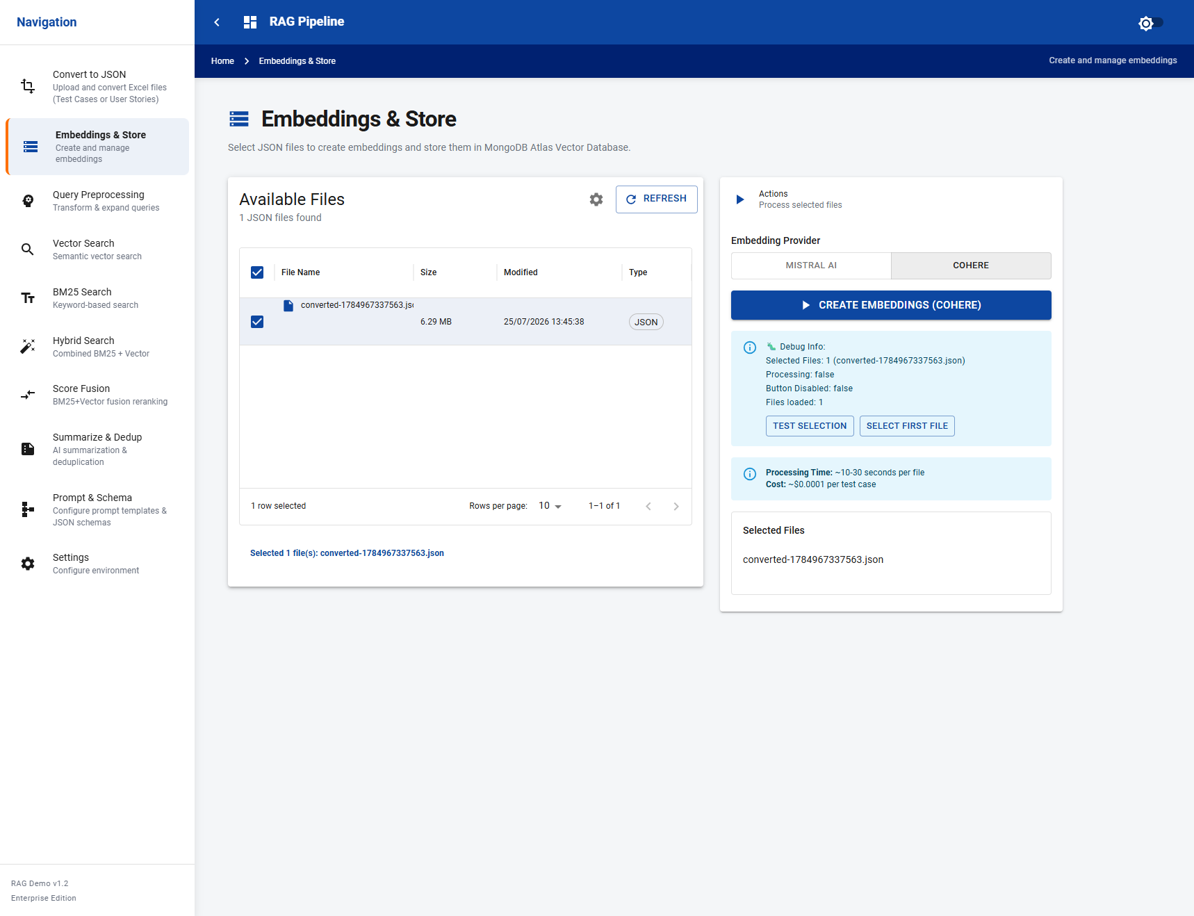
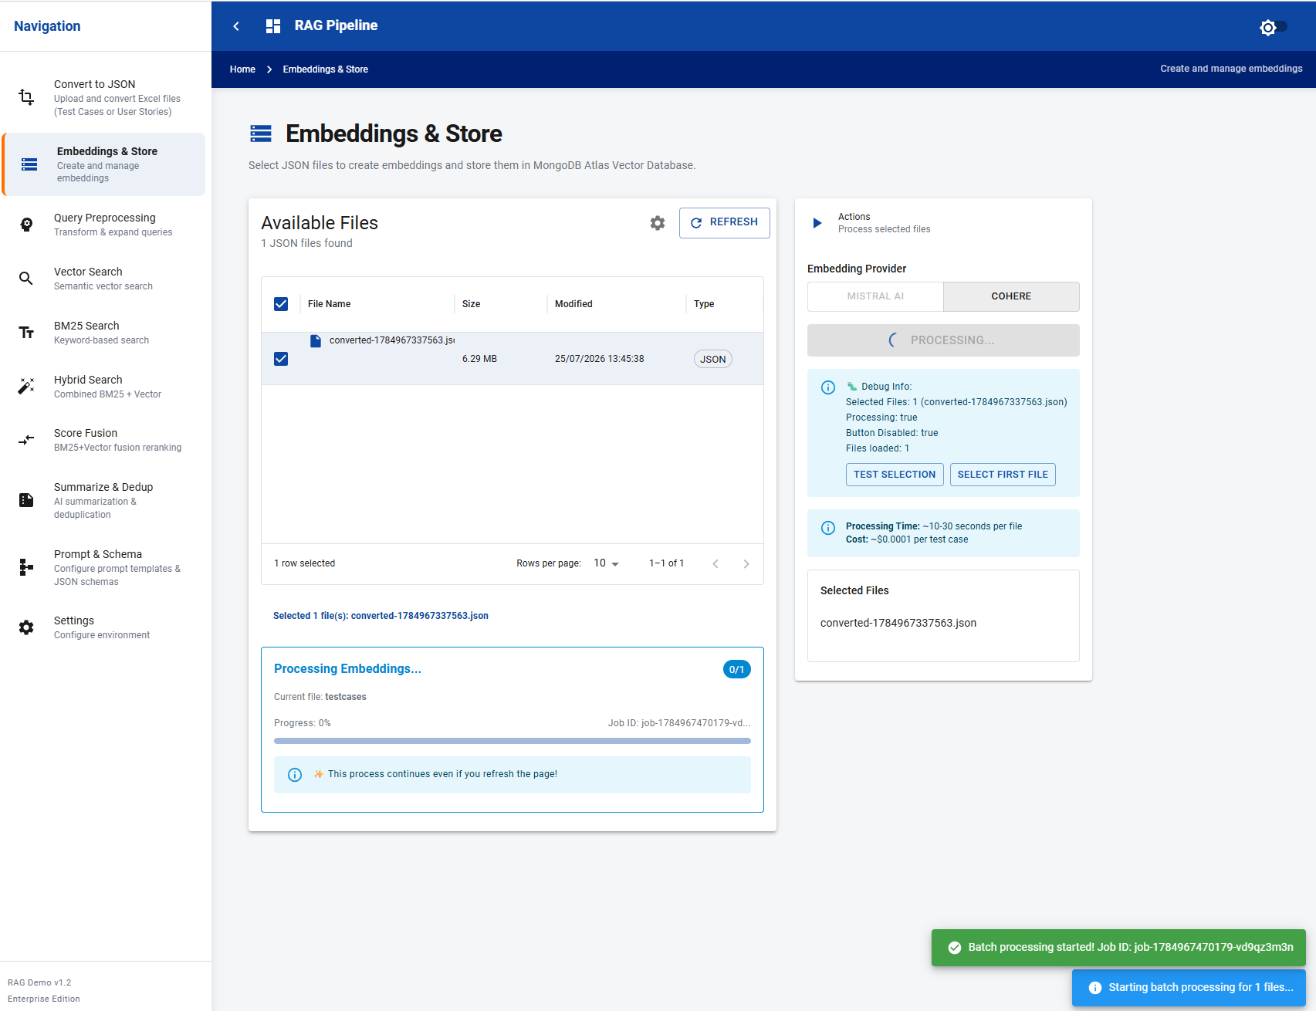

- Embeddings are created in Mongo through Cohere
